Bandana Pachabhaiya Magar (C0916126)

**Question 1 P03-04 – Midtown Publishing**

* Create the ER diagrams in different tabs according to the requirements analysis below
* Export the file as a PDF and submit

**A)** Develop the ERD for a publishing company that wants a database to maintain authors and

books. Each author may write several books. Some authors sign with the publishing company

before they write their first book. Each book may have one or more authors. However, some

books are approved before any authors are assigned. The business rules are as follows:

• Author id, first name, last name, and mobile number are stored for each author

• Book id, title, publication year, and page count are stored for each book. The publi-

cation year and page count are not known until the book is published

• Draw the ERD for the many-to-many relationship(s)

• Use ERD language

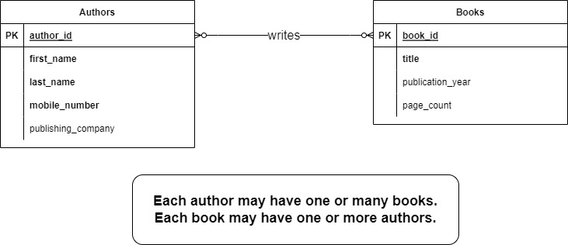

Fig: A

**B)** Resolve the many-to-many relationship between the BOOK and AUTHOR entities

* Some books have two or more authors and they want to keep track of the order in which the author names appear on the book cover
* Identify identifying and non-identifying relationships
* Include ERD language

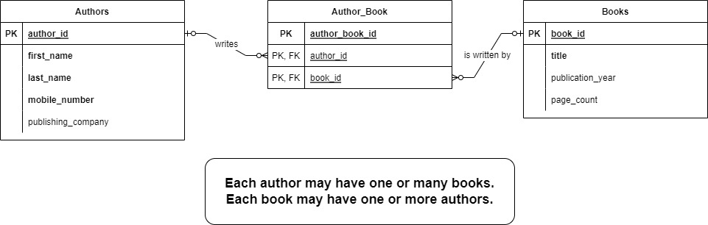

Fig: B